ECE 874 Nonlinear Control **Test 1 Out-of-Class Component** Name ______________________

(20 points total)

Instructions:

1. The test is due on Wednesday February 18 before the start of class at 10:30 AM.
2. You must show all steps in your solutions
3. Your exam solutions are to be your own work, you are not to give or receive assistance of any kind on this exam.





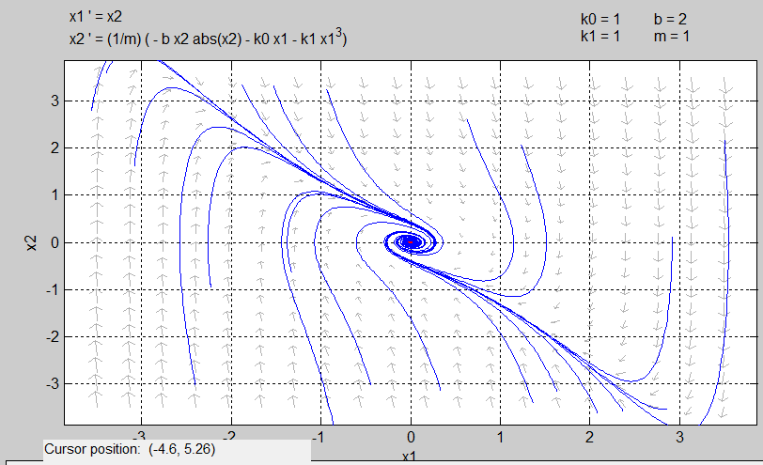

Level curves of (1/2)*x1^2+(1/4)*x1^4+(1/2)*x2^2

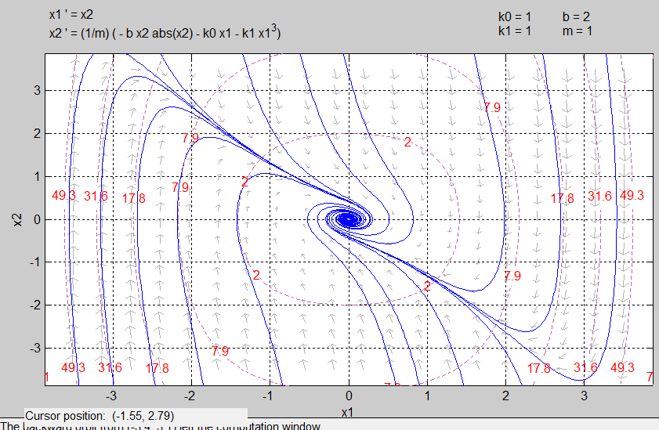

Nullcines

